__________ Birth Preferences

I have been signed off to use the Birth Centre by __________ (VBAC Midwife) and _________ (Midwife)

Please take the time to read my birth preferences so we can achieve the best birth possible. I would like you to remain in the background, taking observations to check on the baby's and my safety, but otherwise not getting involved in my labour, unless I request otherwise. I believe that I know how to give birth on my own, but appreciate the security of having a midwife there to help with the unexpected or emergency situations.

We are using hypnobirthing for our birth and therefore the environment and language is very important to us. Please note that we would appreciate it if you could avoid using the words ‘pain’ or ‘contractions’, and instead talk about ‘comfort’ and ‘surges’.

…………………………………………………………………………………………………..
People attending- _________ (Husband & Dad), __________ (Doula)




…………………………………………………………………………………………………..
I wish to have all information and options explained to me fully- my consent is very important. I would like to avoid all routine vaginal examinations if possible. I do not consent to Stretch & Sweeps or my waters being broken during any examination I may agree to. I will only consider continuous monitoring if absolutely necessary. If continuous monitoring is necessary, I would like to use the wireless monitoring if this is available so that I can continue to move about. I do not wish to be cannulated unless it is essential to do so.



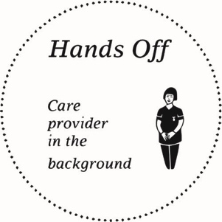


I would like to have a calm and quiet birth. I would like people to knock before entering and to speak in hushed voices. All communication is to go through my birth partners please so that I can labour undisturbed.




…………………………………………………………………………………………………..

I would like to remain active and use whatever position I find comfortable. If I am on the Labour Ward, I would still like access to a birthing pool.
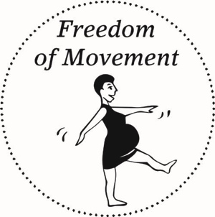




…………………………………………………………………………………………………..

I would like to breathe my baby down so they are born gently and calmly. I would like to follow the lead of my body rather than be coached to push. I would like to be able to bring my baby to my chest immediately after delivery. If it is not possible for me to hold the baby then I would like the baby to have skin to skin time with my Husband.




We would like to observe the “The Golden Hour” - where baby is on my chest immediately after birth and undisturbed skin to skin time for an hour. It is my preference to have a physiological third stage. I would like to wait until my baby has received all of their blood before the cord is clamped and cut. We will be using our own cord tie- please ask _________ or _________ for this. I would prefer to avoid having stitches if possible, so if you think any tear will heal of its own accord, without stitches, please let me know.

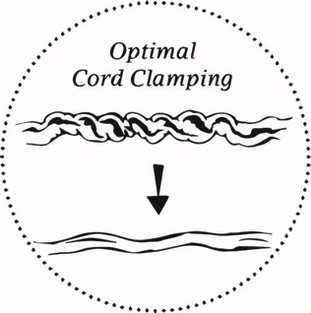





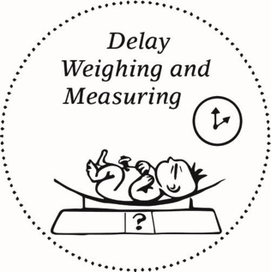


I wish to be discharged as soon as possible.

