**Ratio - Sharing**

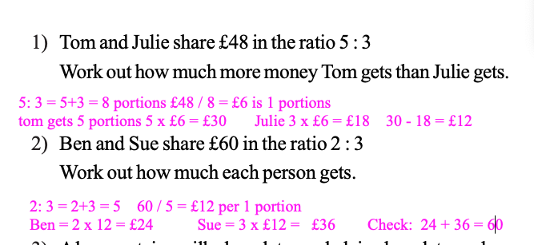

1. 3)  A box contains milk chocolates and plain chocolates only.  
   The number of milk chocolates to the number of plain chocolates is intheratio2:1

There are 24 milk chocolates.  
Work out the total number of chocolates.

1. 4)  Andy, Ben and Claire share £54  
   Ben gets three times as much money as Andy. Claire gets twice as much money as Ben.

How much money does Claire get?

1. 5)  There are some marbles in a bag. 18 of the marbles are blue.

12 of the marbles are red.

a) Write down the ratio of the number of blue marbles to the number of red marbles.  
Give your ratio in its simplest form.

There are some apples and pears in a box.  
The total number of apples and pears is 54.  
The ratio of the number of apples to the number of pears is 1 : 5

b) Work out the number of pears in the box.

1. 6)  A piece of string is180 cm long. Jim cuts it into three pieces in the ratio 2 : 3 : 4

Work out the length of the longest piece.

1. 7)  Sally is13 years old. Tammy is 12 years old. Danny is 10 years old.

Sally, Tammy and Danny share £28 in the ratio of their ages. Tammy gives a third of her share to her mother.  
How much should Tammy now have?